Dreamweaver Workspace Labeling Name____________________

Workspace Overview (label & description)
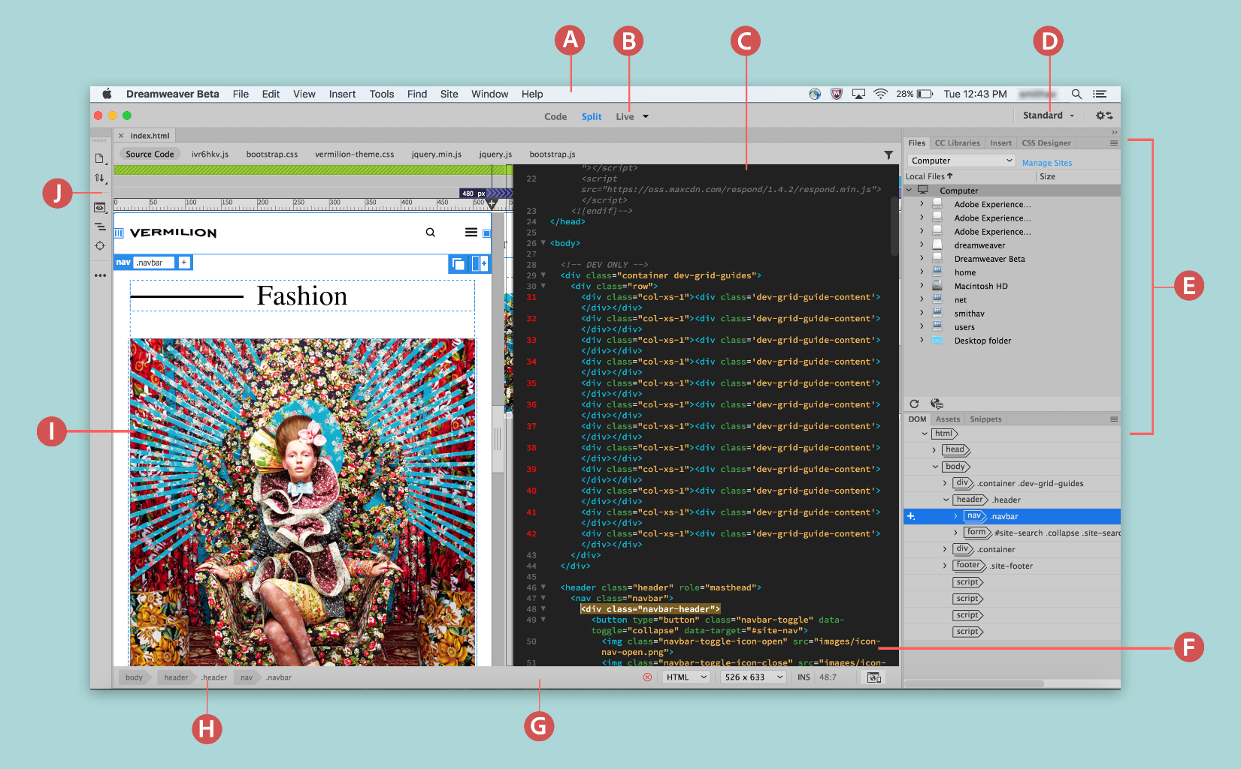
A
B
C
D
E
F
G
H
I
J
Document Window Overview - View Options (description)
Live View
Design View
Code View
Code – Code
Code – Live
Code – Design
Live Code
Status Bar Overview (label & description)
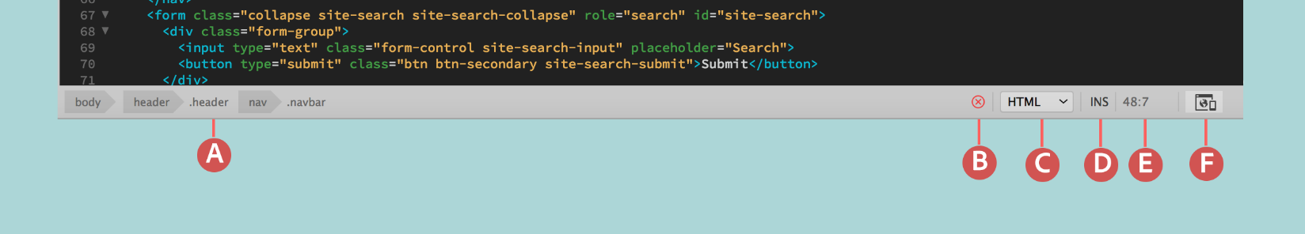
A
B
C
D
E
F
Property Inspector Overview (description)
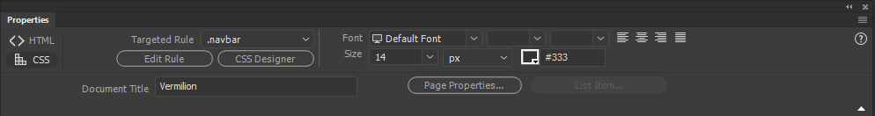

Common Dreamweaver Panels (label & description)
